**Project Design Phase-II**

**Data Flow Diagram & User Stories**

| Date | 31 January 2025 |
| --- | --- |
| Team ID | LTVIP2025TMID49815 |
| Project Name | BookNest |
| Maximum Marks | 4 Marks |

**Data Flow Diagrams:**

A Data Flow Diagram (DFD) is a traditional visual representation of the information flows within a system. A neat and clear DFD can depict the right amount of the system requirement graphically. It shows how data enters and leaves the system, what changes the information, and where data is stored.



**Example:** [**(Simplified)**](https://developer.ibm.com/patterns/visualize-unstructured-text/)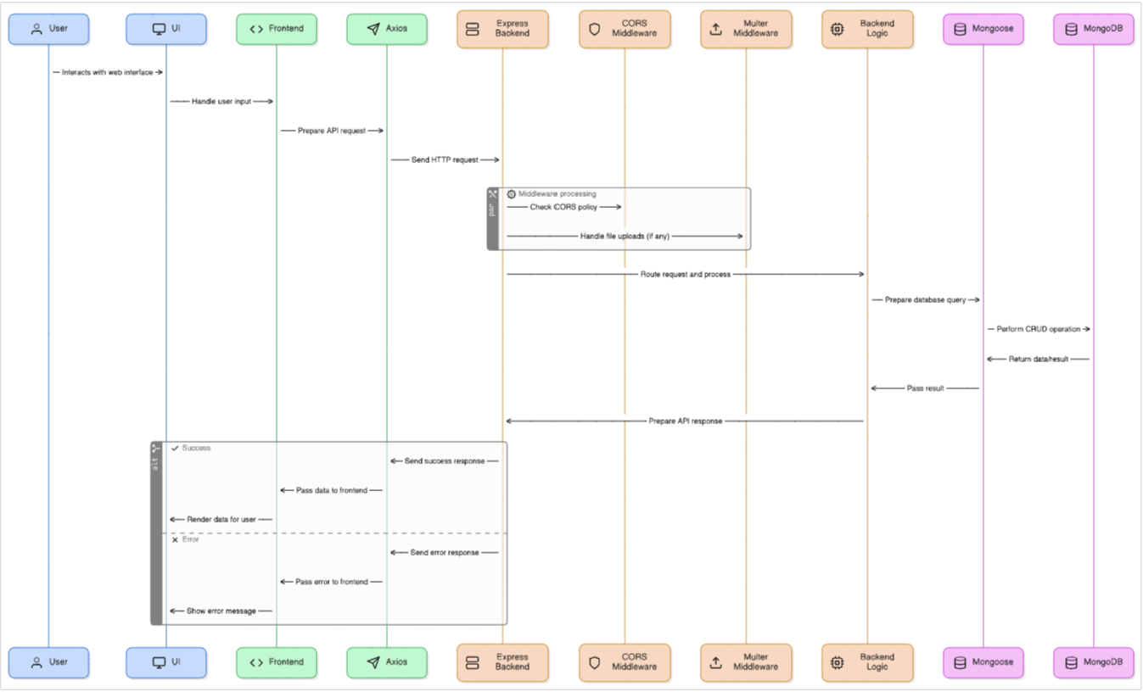

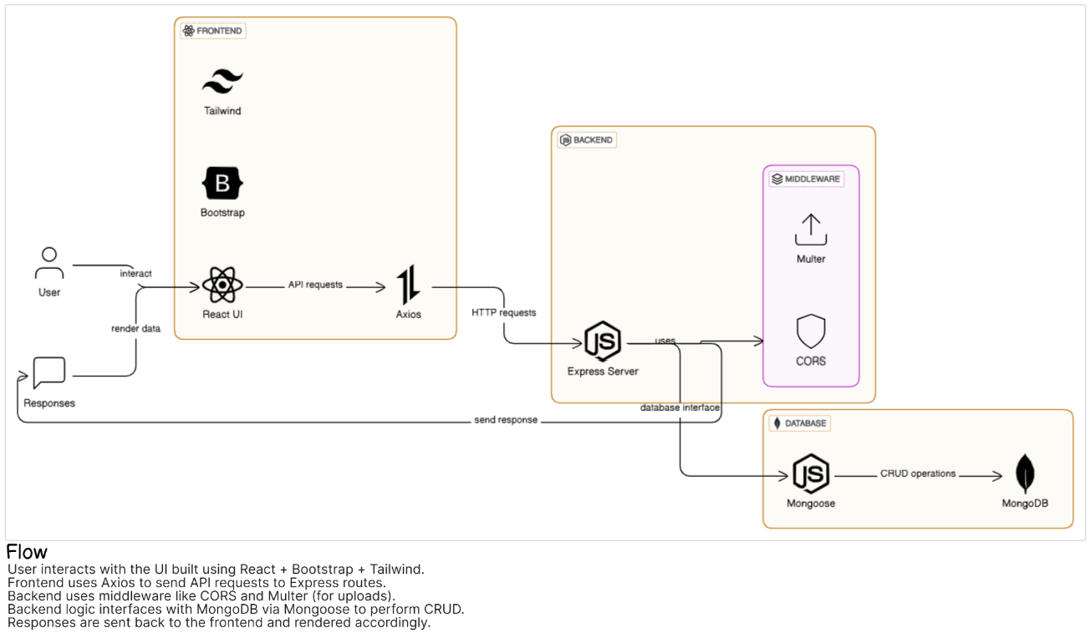

**User Stories**

Use the below template to list all the user stories for the product.

| **User Type** | **Functional Requirement (Epic)** | **User Story Number** | **User Story / Task** | **Acceptance criteria** | **Priority** | **Release** |
| --- | --- | --- | --- | --- | --- | --- |
| Customer (Mobile user) | Registration | USN-1 | As a user, I can register for the application by entering my email, password, and confirming my password. | I can access my account / dashboard | High | Sprint-1 |
|  |  | USN-2 | As a user, I will receive confirmation email once I have registered for the application | I can receive confirmation email & click confirm | High | Sprint-1 |
|  |  | USN-3 | As a user, I can register for the application through Facebook | I can register & access the dashboard with Facebook Login | Low | Sprint-2 |
|  |  | USN-4 | As a user, I can register for the application through Gmail |  | Medium | Sprint-1 |
|  | Login | USN-5 | As a user, I can log into the application by entering email & password |  | High | Sprint-1 |
|  | Dashboard |  |  |  |  |  |
| Customer (Web user) | Book Browsing | USN-7 | As a user, I can browse books by category, author, or price. | Books are filtered and displayed correctly | High | Sprint-2 |
|  | Wishlist | USN-8 | As a user, I can add books to my wishlist to purchase later. | Books appear in my wishlist section | Medium | Sprint-3 |
|  | Cart & Checkout | USN-9 | As a user, I can add books to cart and proceed to checkout. | I can purchase books and see order confirmation | High | Sprint-3 |
| Customer Care Executive | Ticket Handling | USN-10 | As a support agent, I can view and respond to customer complaints. | I can respond and update ticket status | Medium | Sprint-4 |
| Administrator | User Management | USN-11 | As an admin, I can add or remove users and assign roles. | I can manage user roles and accounts | High | Sprint-4 |
|  | Inventory Management | USN-12 | As an admin, I can add, update, or remove books from inventory. | Changes reflect in the public catalog | High | Sprint-4 |
|  |  |  |  |  |  |  |
|  |  |  |  |  |  |  |